The Chamber is organized for the purpose of advancing the commercial, industrial, civil, cultural and general interests of Mechanicville and Stillwater.

How does the Chamber work for you and your community?
What you don't know might surprise you!

It's your Voice/Business Agent/Spokesman/Sales Manager/Information Bureau/Education Seminar Center and more....
- Replies to hundreds of inquiries about our area businesses completely, expeditiously, courteously, creating favorable impressions and building public esteem...

- Releasing a new website containing information about our area , community events, attractions and local businesses.

- Represents you as a collective voice on questions/concerns of taxation, legislation, and historic preservation, city services to protect and enhance your business...

- Programs, seminars, services tailored to help your business and employees are successful.

- Promotes partnerships reflecting your area's rich tradition of friendliness and hospitality.

- Source of for up-to-the-minute information helping you conduct your business...statistical data, facts on business trends, population, employment practices and developments.

- Rallying point for every civic movement whose objective is the benefit of the community.

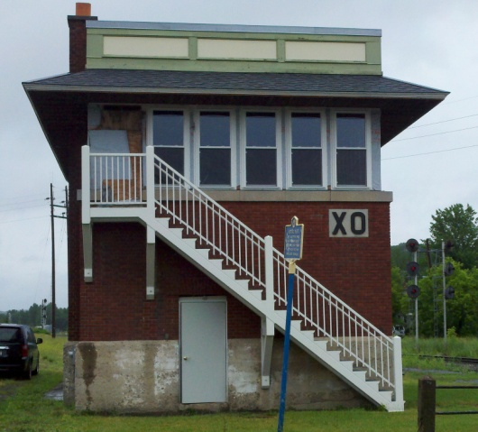
For listing Community Events:
Barbara Corsale President
more information contact: Mechanicville Stillwater Chamber of Commerce
P.O. Box 467 Mechanicville, New York 12118
Phone (518) 664-7791 Fax (518) 664-0826
MechanicvilleStillwaterChamber@albany.twcbc.com

Applicant's Name / Business Name _____________________________________________________

Residence Address __________________________________________________________________

Business Address____________________________________________________________________

Phone ______________________________________________________________________________

Email_______________________________________________________________________________

Type of Business
_____Retailer _____Wholesaler _____Manufacturer _____Service _____Profession _____Other

Chief products or services________________________________________________________________
I agree to pay the annual dues of $150.00 (501c - $125.00) for the calendar year of July 1,2017 to July 1, 2018 and annually thereafter in accordance with the bylaws of the Chamber, until such time as my membership is terminated.

Signature: __________________________________________________________ Date: ________

